Come join Ms. Arty Pants for a fun afternoon of
painting at Hazelwood Elementary School!

When: Friday, December 8 at 1:00p.m. till 2:30
Who: Pre-K -2nd graders
This event will occur during school hours. Your child will go home at the end of the day as usual!

Cost: $10.00 for 8X10 canvas pre-sketched picture.
(NO REFUNDS and paintings will be distributed the following week)

Students may select multiple pictures.

Make Checks Payable to Hazelwood PTO

PTO Plott Hound Christmas Shop

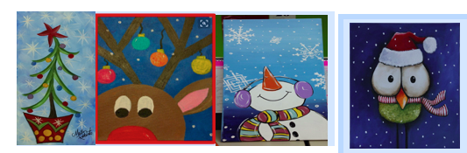
Please complete the following information and return to your student’s teacher by Thursday, December 7 at 3:00. No late forms will be accepted.

BE PROACTIVE: All participates that return the registration form with money before Friday, December 1 will be entered into a drawing for a Hazelwood draw string bag!

Students Name: ________________________________________________________________________

Teacher’s Name and grade: ___________________________________________________________

Please mark the number of pictures and write your words in the blank provided.
We will only write what is listed on this form!!
There is a display of the prints in the main lobby of our school.

________: Christmas Tree:
3 words: ______________________________________________________
________: Reindeer
3 words: ______________________________________________________
________: Snowman
3 words: ______________________________________________________
________: Christmas Owl
3 words: ______________________________________________________

Total Number of pictures: ___________Total amount Enclosed: _________________

