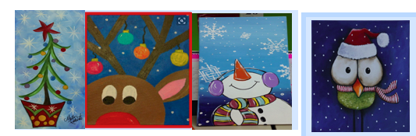
Please complete the following information and return to your student’s teacher by Thursday, December 7 at 3:00. No late forms will be accepted.

BE PROACTIVE: All participates that return the registration form with money before Friday, December 1 will be entered into a drawing for a Hazelwood draw string bag!

Students Name: ________________________________________________________________________

Teacher’s Name and grade: ___________________________________________________________

Please mark the number of pictures and write your words in the blank provided.
We will only write what is listed on this form!!
There is a display of the prints in the main lobby of our school.

________: Christmas Tree:
3 words: ______________________________________________________
________: Reindeer
3 words: ______________________________________________________
________: Snowman
3 words: ______________________________________________________
________: Christmas Owl
3 words: ______________________________________________________

Total Number of pictures: ___________Total amount Enclosed: _________________

Come join Ms. Arty Pants for a fun afternoon of
painting at Hazelwood Elementary School!

When: Friday, December 8 at 3:00p.m. till 5:00
Who: 3rd-5th^{d} graders
You will pick your child up through the car line. You must have a car tag.
Cost: $10.00 for 8X10 canvas pre-sketched picture and snack
(NO REFUNDS and paintings will be distributed the following week)

Students may select multiple pictures.

Make Checks Payable to Hazelwood PTO

PTO Plott Hound Christmas Shop

