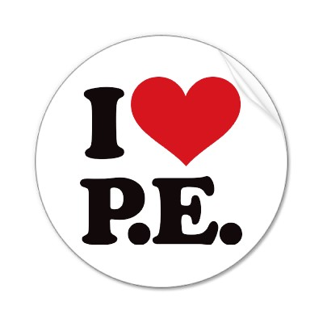
Physical Education Winter Newsletter

What’s going in Hazelwood P.E?

At Hazelwood my goal is to teach students Physical Education with a purpose. The #1 purpose at Hazelwood is for students to develop fun sport and fitness skills that promote lifelong healthy habits. Continue reading to see how we are working to accomplish this in your child’s grade level.

Kindergarten-2nd Grades
K-2 students will continue to learn and review locomotor and manipulative skills as the school year continues. We are working hard to master throwing, catching, rolling, dribbling, and kicking skills. It is important that students have the ability to properly perform these skills. They are the building blocks for what students will learn as they move to 3rd, 4th, and 5th grades. In the coming weeks we will also start learning about the heart and the role cardiovascular endurance play in being a healthy, happy person.

3rd -5th Grades
3rd through 5th grade students have been working hard to improve Basketball skills during P.E. This has worked out very well, because of the number of students involved in local recreation leagues. Students are also working very hard to improve fitness scores. We will continue to talk about the 5 components of a fitness and ways to improve each of them. We will also be starting Frisbee, soccer, and a volleyball unit at the year continues.

Thank you for your continued support of the HES Physical Education program! If you have any questions about what we are doing here at Hazelwood please email me at cconard@haywood.k12.nc.us.
Casey Conard

“Physical fitness is not only one of the most important keys to a healthy body, it is the basis of dynamic and creative intellectual activity.”

John F. Kennedy

