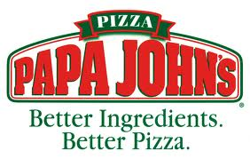 | Papa John’s Pizza Cards for $10  Papa John's pizza cards are still available for purchase in the school office for $10. Take advantage of over $100 in saving for just $10 per card.

Ingles Advantage Cards  “Tools for Schools”  Remember to link your Ingles Advantage cards to HES. For those who linked their cards previously, they must be re-linked each new school year and this can be done online or in the school office. | 

Upcoming Events

- Mardi Gras Sock Hop on Friday, February 8 from 6-8 p.m.

- HES Spirit Items are available for purchase in the office. Get yours today! Items include water bottles, drawstring bags & car magnets with our HES Plott Hound logo.

PTO BOARD
- President, Jessica White
- Advisor, Julie Hendrix
- Vice President, Judy Dodson
- Advisor, Amanda Parton
- Secretary, Mary Beth Dorgan
- Advisor, Christy Yazan
- Treasurer, Beth Plisko
- Advisor, Jamie Powell
- Principal, Susan Savage
- Lead Teacher, Ann Trader
- Title I Teacher, Becky Pope
- Teacher Rep, Stephanie Ott
Contact us if you have any questions!

HES PTO welcomes all parents and families to share your ideas with us on how we can serve and support our school and students. Please contact the office to share your ideas or to learn how you can become involved!
Save your Box Tops and help us earn money for our school.

Come out to support HES Bojangles Night--Thursday,
Feb. 21 from 5-8 pm

Hazelwood Elementary PTO Newsletter
February 2013 Issue 4 Susan Savage, Principal
Jessica White, PTO President
Happy New Year from the Hazelwood PTO!
The HES PTO is making plans for the spring and looking forward to fun activities that benefit our students and our school. As always, we invite parent volunteers to take part in PTO events and get involved with our school community through the PTO.

Bojangle’s Night
Third Thursday of each month
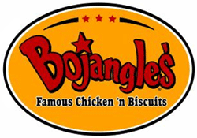
Wendy’s Night
First Tuesday of each month




