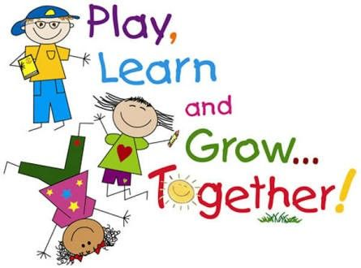

Clyde Elementary School

Supply List

- Terry cloth bath-size towel or beach towel for nap time (We will not be using rest mats this year.)
- Backpack (standard size, no wheels)
- 1 Box of 24 Crayola crayons
- 6 regular glue sticks
- Box of Crayola washable markers
- 1 (4 pack of EXPO dry-erase markers)
- 1 (12 count) package of Ticonderoga #2 pencils
- $7 fee for: 1 1½ 3-ring binder, take-home folder, writing folder, and pencil pouch, marbled composition book (purchased by teacher)

