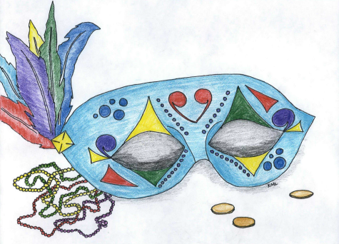
Queen Candidates
Noralynn Grindstaff
Niki Henry
King Candidates
Jason Greene
Dr. John Highsmith
Travis Hyatt
Ball
Mardi GRAS
Saturday, March 1st

