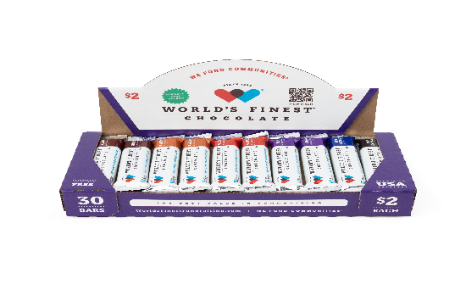

BETHEL Elementary School PTO
2025 Fall Fundraiser
The funds we raise from this fundraiser are going to help us support our teachers throughout the year for instructional supplies, classroom materials and to enrich our student's educational experience!

You can make the difference! Please support Bethel Elementary School by checking out at least one box of WFC and helping your child sell the chocolate to family, friends, co-workers and businesses.

Sale Begins: Tuesday, August 26th
Sale Ends: Tuesday, September 16th
All Prizes are cumulative (the more you sell, the more prizes & cash you earn) and based on ALL money due, being turned in no later than Tuesday, September 16th.
Student Incentives: There will be lots of really cool prizes, Chick Fil A cards and you can even get out of class to attend a Pig Race & Ice Cream Party! All prize information will go home Tuesday, August 26th!
If you find a Golden Ticket inside your box of chocolate, turn in your $60 along with the Golden Ticket and you win a 1-pound World’s Finest Chocolate Bar!

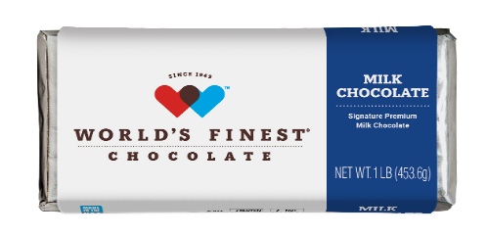

---------------------------------- Cut off below and return to school ------------------------------------

Chocolate Check-Out Form

All Chocolate must be paid for before additional Chocolate may be checked out

I would like to check out 1 box of 30 $2.00 WORLD’S FINEST CHOCOLATE BARS ($60/Box) and help Bethel Elementary School PTO raise needed funds to support our teachers. I understand I am responsible for the chocolate, including eaten, stolen or lost chocolate and turning $60 into the school no later than Tuesday, September 16th.

NO Chocolate can be returned once it is checked out.

Parents: please help us! Please replace all small bills and change with larger denominations such as $10 OR $20 BILLS or a check made out to Bethel Elementary School PTO! THANK YOU!

STUDENT’S NAME:_________________________________________TEACHER:_____________________
PARENT’S SIGNATURE:___________________________________________________________________
PHONE #:________________________EMAIL:________________________________________________

