Bethel Elementary
First Grade Supply List
- Large Pink Erasers (3pk)
- Glue Sticks (12 pk)
- TICONDEROGA Pencils (24 pk)
- Book Bag (no wheels)
- Plastic Pocket Folder w/ Middle Clasp (2)
- White 3-Ring 1” Binder w/ Clear Front
- Box of 24 Crayola Crayons
- Clip Board
- Box of Crayola Colored Pencils
- Pack of 1x1 Post-It Notes
- 2 highlighters
- 1 pack of thin dry erase markers
- Marble Composition Books (2)- Primary Ruled with room for picture & 2 Primary Ruled full page
(see picture below)
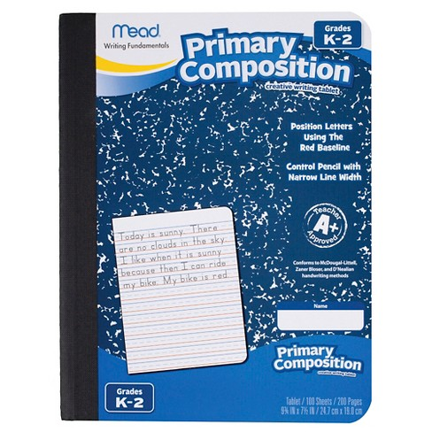
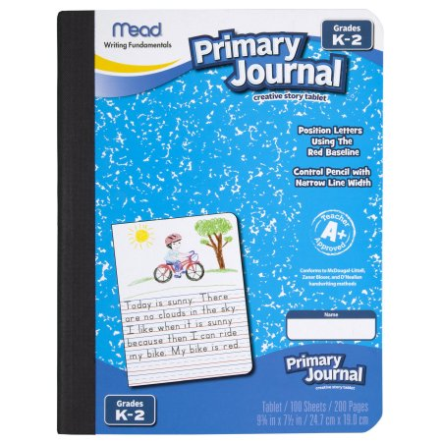
Primary Ruled full page no picture at top Primary Ruled with picture

