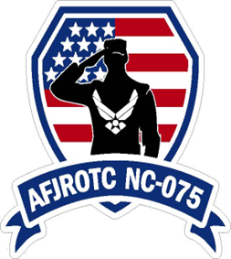
Tuscola HS AFJROTC Boosters

Presents

Blue Ridge Bomber Annual Car Show
Sponsors: Hattons Towing & Mountain Euro
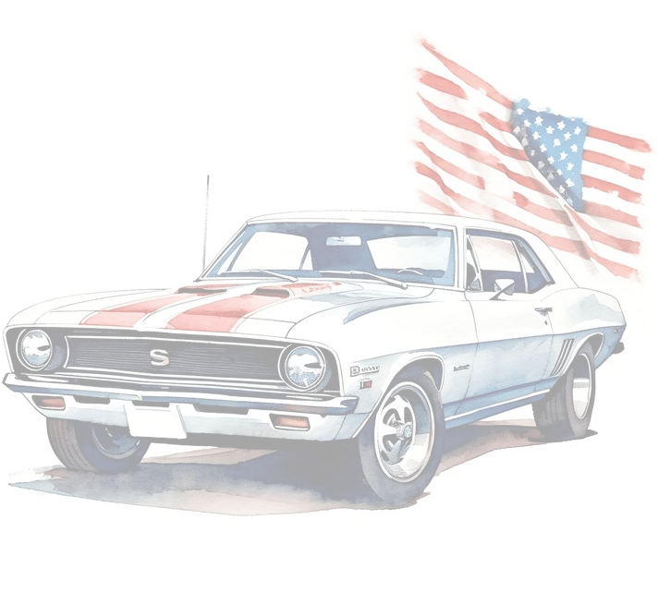
March 21st, 2026
10am to 1pm
Registration Starts at 09:30 am
Tuscola HS Parking Lot * Waynesville, NC
Entry Fee: $25 (Pay at the gate, cash, card or Venmo)
All Cars, Trucks, Jeeps, Motorcycles, Heavy duty vehicles welcome!
Door Prizes | 50/50 | Trophies for multiple categories
New this Year!
Blue Ridge Bomber Tiny Top Guns Power Wheel Derby
$5 entry fee
Ages 3-9 (2 age categories for race)
Onsite food purchases are available thru Appalachian Smoke
All proceeds go to NC-075 AFJROTC Parent Boosters to aid the cadets in serving our community and the Veterans of WNC through community services and special ceremonies.

