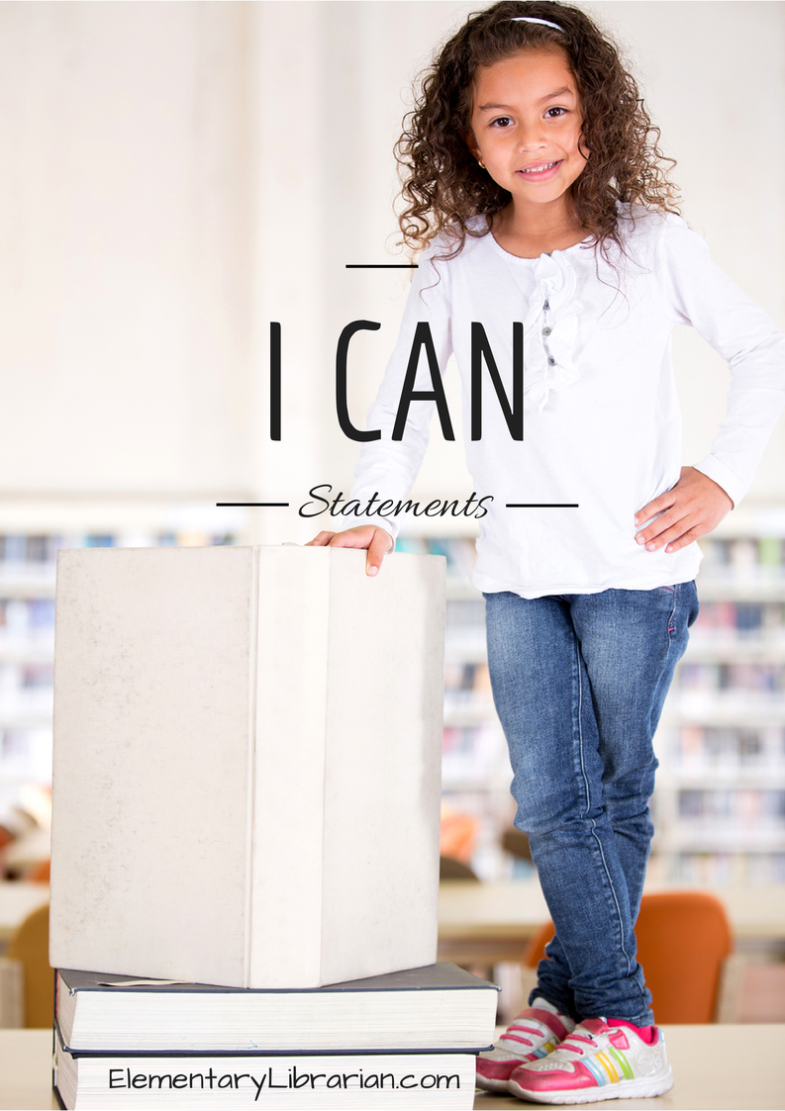

I can describe activities I'd like to do in library class during the school year.
I can follow directions given by my teacher.
I can choose proper book care behaviors.
I can follow library rules. I can follow directions for checking out books.
I can describe this month's library activities.
I can identify a book's characters.
I can identify the parts of a book.
I can describe the job of an author and illustrator.
I can retell a story.
I can retell a story.
I can list facts.
I can tell the difference between fiction books and nonfiction books.
I can describe this month's library activities.
I can sort books into 2 categories: fiction or nonfiction.
I can read sight words.
I can blend sounds to read words.
I can retell a story.
I can retell a story.
I can compare two fiction stories.
I can choose a favorite story.
I can help plan the research project about an ocean animal.
I can name things I'd like to learn about the chosen ocean animal.
I can help my teacher list things I've learned about the chosen ocean animal so far.
I can help my teacher list things I've learned about the chosen ocean animal so far.
I can help my teacher list things I've learned about the chosen ocean animal so far.
I can help my teacher choose the most important facts to include in the research presentation.
I can create a poster about an ocean animal.
I can present facts about an ocean animal to the rest of my class.
I can recognize steps to complete a task.
I can suggest ideas for a how-to book.
I can help write a how-to book.
I can help write a how-to book.
I can describe this month's library activities.
I can put a story in order.
I can put words in ABC order.
I can sort words into their proper categories.
I can describe this month's library activities.
I can describe a poem.
I can name characters, setting, and major events in a story.
I can read sight words.

