Meadowbrook Elementary Reading Challenge
#mesreadingchallenge
#messtrong
Every day there will be a new challenge. Please take a picture of yourself reading there and let us see.
Here are the ways that you can share.
- Post on our Facebook page!
- Share your picture on the Class or School Dojo Page
- Share them on Google Classroom
- No Internet- save them until we return to school!

Challenge 1  Go outside and read a book! Take a picture and share.   | Challenge 2  Give your book a new title. Post a picture of yourself with the book and the new title cover page! | Challenge 3  Read a book with a flashlight!  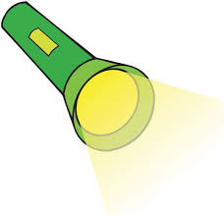 | Challenge 4  Act out a scene from your book. Use materials from the house and ask family members to participate. | Challenge 5  Build a fort. Take a picture of yourself reading in your fort.  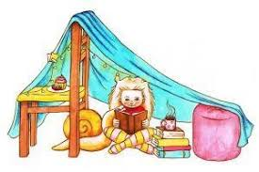
Challenge 6  Read your book to a stuffed animal or real pet.   | Challenge 7  Pick your favorite part in the book and make a comic strip of this. Post a picture of your book and this scene. | Challenge 8  Tell us how you feel about your book. Would you recommend it? Thumbs up or down. Take a picture. | Challenge 9  Get under your favorite blanket and read. Don’t forget to post a picture. | Challenge 10  Stop, Drop, and read at 8:32 (am or pm) Make sure the clock is in your picture.  